Multi tenant and Single Tenant concepts in Pega

In an application from the server side we will be having single tenant and multi tenant applications

An application will have the Partitions where a particular environment can host more than one application and it can serve different users at the same time..

Single tenant system is where you can deploy one application to the only one environment

With each operator they will have single dedicated system..

How to see in pega means by seeing instances in the class

Data-Admin-Tenant and check for instances

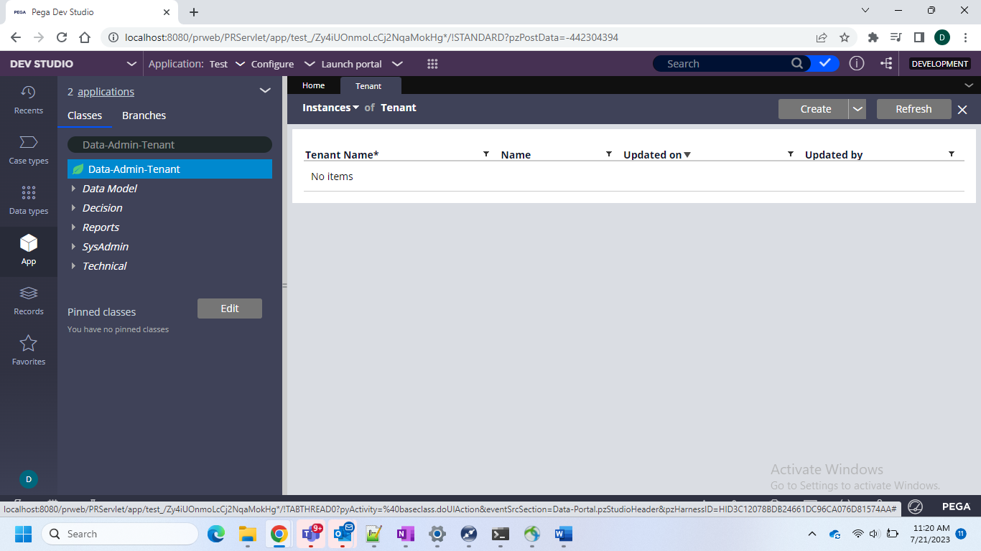

Not only here you can check in clipboard

Under system pages under that pxprocess > pxadminsystem and in this we can see pyMT is false so this is since personal server so this is single tenant server

It means simply if 2 application like KFC dominos so kfc cant see dominos and dominos cant see KFC

They can see each other logic or touch their data but can share layers like CS or CDH without installing another pega server